* Database name is **Companydata**
* Table name is Employee

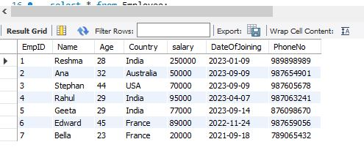

1. Write an SQL  statement to display specific columns such as names and salaries for all Employees

Ans:- **select Name, Salary From Employee;**

2.  Write a SQL query to locate an employee who lives in ‘India'. Return the

employee’s name and country.

Ans:- **select * from employee where Country = "india";**

**select * from employee where Name = "Reshma";**

3. Write an SQL statement to return the name of an employee whose salary

is more than 40000.

Ans:- **select * from employee where salary >=40000;**

4. Write a SQL statement to return the name of an employee whose salary is

between 50000 and 80000.

Ans:- **select * from employee where salary between 50000 and 80000;**

5. Write a SQL query to find the employee whose ages are higher than or

equal to 30. Order the result by age in descending.

Ans:- **select * from employee where age >=30;**

**select age from employee order by age desc;**

6. Write a query to display the names of employees in the order of their

joining date.

Ans:- **select DateOfjoining from employee order by DateOfJoining;**

7. Write a query to count the number of employees.

Ans:- **select count(*) from employee;**

8. Write a query to display the name and salary of an employee who either

lives in France or Australia.

Ans:- **select * from employee where country = "France" Or Country**

**="Australia";**

9. Write a query to delete the records of Ana.

Ans:- **delete from employee where name= "Ana";**

10. Write an SQL query to find the lowest salary of an employee.

Ans:- **Select min(salary) from employee;**

11. Write an SQL query to find the highest salary of an employee.

Ans:- **Select max(salary) from employee;**

12. Write an SQL  query to display the names of employees

        which ends with an ‘a’.

Ans:- **select * from employee where name like "%a";**

13. Write an SQL query to find the number of employees living in each

country.

Ans:- **select distinct (country) From employee;**

14. Write a query to find the highest salary of employees in each country

having a salary of more than 70000.

Ans:- **select distinct (country) where salary >=70000 from employee;**

15. Write a query to add an email column in the existing employee table.

Ans:- **alter table employee add Email varchar (70);**

16. Write a query to update the age of an employee to 55 and salary to 90000

where id is 4.

Ans:- **update employee set Age = 55 , Salary = 90000 where**

**EmpId=1;**

17. Write a query to rename a column country to address.

Ans:- **Alter table employee rename Column Country to address;**

18. Write a query to delete the age column.

Ans:- **alter table employee drop Column age;**